Crash Guard: A Smart Helmet with Alcohol Detection and
Crash Alert for Motorcycle Rentals

A Capstone Project
Presented to the Faculty of
College of Computing Studies
Pampanga State University

In Partial Fulfillment
of the Requirements for the Degree
Bachelor of Science in Information Technology

By:

Antonio, Mackenzie E.
Del Rosario, Jan Miguel R.
Galura, Lanz Endrei N.
Maniago, Joshvy P.
Tayag, Sean John O.
Tulio, Willy T.

November 2025
APPROVAL SHEET

This capstone research project entitled "Crash Guard: A Smart Helmet with Alcohol Detection and Crash Alert for Motorcycle Rentals", presented orally and submitted by Antonio, Mackenzie E., Del Rosario Jan Miguel R., Galura Lanz Endrei N., Surname, Maniago Joshvy P., Tayag Sean John O., and Tulio, Willy T. as partial fulfillment of the requirements for the degree of Bachelor of Science in Information Technology has been examined and hereby recommended for approval and acceptance.

MYKA A. CRUZ, LPT, MIT
Capstone Instructor

ANICIA L. FERRER, MSIT
Adviser

Capstone Research Project Panel of Examiners

Examined and passed by the Capstone Research Project Panel of Examiners on
November 17, 2025

ALDREYN W. PINEDA |  | RUSSEL JOHN I. HIPOLITO
Member |  | Member

JULIETA M. UMALI, MSIT, MAIE
Member

Accepted and approved in partial fulfillment of the requirements for the degree,
Bachelor of Science in Information Technology.

RONNEL C. DELOS SANTOS, DIT
Chairperson

JOEL D. CANLAS, MIT, MBA
College Dean

ACKNOWLEDGEMENT

The researchers wish to express their heartfelt appreciation to their dedicated adviser. Ms. Anicia L. Ferrer, for her constant guidance, support, and encouragement all through the development of this study. Her best advice and expertise largely contributed to the successful completion of the study.
The researchers wish to express their sincere gratitude to their panelists, Mr. Russel John I. Hipolito, Ms. Julieta M. Umali, and Mr. Aldreyn W. Pineda, for their helpful suggestions, constructive feedback, and professional insights contributed to improving the study's quality.
The researchers extend their serious appreciation to their parents, who have shown them their continuous support, understanding, and encouragement which served as their constant strength during this journey.
They also wish to thank everyone who participated and aided the data collection for this research. Their participation and willingness to help made the research possible.
Finally, the researchers want to thank Almighty God for sustaining them from the beginning until the completion of this study through His magnificence, and without His goodness and grace, this researcher would not exist.

DEDICATION

This research project is lovingly dedicated to my family and loved ones, whose unwavering support, patience, and encouragement have sustained me throughout this academic journey. Their belief in my capabilities has inspired me to persevere, stay focused, and strive toward excellence, even in challenging moments. I owe much of this achievement to their constant guidance and love.
I would also like to extend my sincere gratitude to my adviser, Ms. Anicia L. Ferrer, whose dedication, expertise, and thoughtful guidance greatly shaped the direction and quality of this study. Her consistent support and insightful feedback have been invaluable throughout the development of this work. My appreciation likewise goes to our panelists Mr. Russel John I. Hipolito, Ms. Julieta M. Umali, and Mr. Aldreyn W. Pineda for their constructive comments and professional insights that helped refine and strengthen this research.
To my friends, classmates, and everyone who offered help, encouragement, or assistance in big or small ways, thank you. Your presence and support made this journey more meaningful and manageable.
Above all, I dedicate this work to Almighty God, whose guidance, protection, and blessings made this accomplishment possible from start to finish.

ABSTRACT
Crash Guard is an IoT-enabled smart helmet developed to enhance motorcycle safety, particularly for motorcycle rental services. The system integrates alcohol detection, crash alert, and ignition lock mechanisms to reduce alcohol-related accidents and promote proper helmet usage.
The helmet uses an alcohol sensor to measure the rider’s breath alcohol concentration (BAC) before allowing the motorcycle to start. If the detected level exceeds the allowable limit or if the helmet is not worn, the ignition system is automatically disabled. Additionally, motion and force sensors are used to detect crashes. Once an accident is identified, the system automatically sends an emergency alert with real-time GPS coordinates to pre-registered contacts via SMS using the Telegram application.
The study presents the design and development of the smart helmet and evaluates its potential to improve rider safety, support motorcycle rental operations, and enable faster emergency response. The results indicate that Crash Guard offers a practical and effective solution for enhancing road safety through IoT-based technology.
Keywords: smart helmet, IoT, alcohol detection, crash alert, motorcycle safety

TABLE OF CONTENTS
 | Page
Title Page.………………………………………………………………………. | i
Approval Sheet..………………………………………………………………... | ii
Acknowledgement……………………………………………………………… | iii
Dedication………………………………………………………………………. | iv
Abstract…………………………………………………………………………. | v
Table of Contents……………………………………………………………….. | vi
List of Tables…………………………………………………………………… | viii
List of Figures…………………………………………………………………... | ix
List of Appendices……………………………………………………………… | x

Chapter I | The Problem and its Background
 | Introduction……………………………………………………... | 1
 | Purpose and Description………………………………………... | 3
 | Objectives of the Study……………………………………........ | 5
 | Significance of the Study………………………………………. | 7
 | Scope and Limitations………………………………………….. | 8
 | Conceptual Framework……………………………………........ | 10
 | Definition of Terms…………………………………………….. | 11
Chapter II | Review of Related Literature
 | Related Literature……………………………………………….. | 14
 | System Technical Background…………………………………. | 23
Chapter III | Methodology of the Study
 | Research Design………………………………………………… | 25
 | Software Development Methodology…………………………... | 26
 | Requirements Analysis and Documentation………………......... | 27
 | Research Tool and Instrument….………………………………. | 36
 | Respondents of the Study………………………………………. | 36
 | Sampling Techniques…………………………………………… | 47
 | Implementation Plan and Results……………………………….. | 54
Chapter IV | Results and Discussion
 | Results and Discussion…………………………………………. | 55
Chapter V | Summary, Conclusion and Recommendation
 | Summary………………………………………………………... | 64
 | Conclusion……………………………………………………… | 66
 | Recommendation……………………………………………….. | 67
References | …………………………………………………………………... | 69
Appendices | …………………………………………………………………... | 70

LIST OF TABLES
Table |  | Page
1 | Sample Size Distribution using Roasoft Calculator………………...... | 46
2 | Likert Scale Value…………………………………………………...... | 47
3  4  5  6  7  8  9  10 | Number of Respondents of Crash Guard…………………………......  Responses of the Parcticipants in the Pre-Survey Questionnare…......  Assessment of the Respondents on the Functionality of Smart Helmet.  Assessment of the Respondents on the Realibility of Smart Helmet.....  Assessment of the Respondents on the Usability of Smart Helmet.....  Assessment of the Respondents on the Effeciency of Smart Helmet.....  Assessment of the Respondents on the Security of Smart Helmet.....  Assessment of the Respondents on the Maintanibility of Smart Helmet..…………………………………………………......……...... | 51  56  56  59  60  61  62  63
LIST OF FIGURES
Figure |  | Page
1 | INPUT PROCESS OUTPUT………………………………………… | 19
2 | Iterative Model…………………………………………………...…… | 35
3  4  5  6  7 | System Flowchart Design………………………………………………  Block Diagram………………………………………………...………  Helmet Circuit Diagram………………………………………………  Motorcycle Circuit Diagram…………………………………………  Schedule Timeline…………………………………………………… | 40  41  42  44  53

LIST OF APPENDICES
Appendix |  | Page
A  B | Request Letter(Adviser)…………………………………………… | 15
2 | Verbal Interpretation……………………………………………….. | 16
3 | Grand Mean………………………………………………………… | 17

Chapter I
The problem and its Background

Introduction

In the 21st century technology becomes one of the most important aspects in our daily lives, reshaping the way of people do work, how people converse with others, and how people interact with surroundings. Starting from the convenience of using smartphones that keeps people in touch with other people to the transportation technologies that makes travelling more efficient. Travelling is important as it allows people to carry out activities ranging from personal travelling for vacation, visiting family, and running errands to commuting to school or work having the ability to travel to places easily provides us ease in managing our time.

Ranging from land-transport vehicles to aircraft, motorcycle play a vital role in reshaping the life of people by enabling a fast and efficient way to travel or to transport goods. It also helps minimize the travel time which can lead in a much more productive use of time. In the emergency service sector wherein, they rely on vehicles for faster response where every second matters having a vehicle like ambulance or fire trucks helps them respond faster and prevent or mitigate the number of casualties.

In this modern world people cannot deny that motorcycle is still one of the fastest ways to travel especially on congested roads mainly caused by traffic, most people these days often use ride-hailing apps or sometimes go for motorcycle rentals. According to Ali (2021), These ride-hailing services use the fare collection system through the administration of the application. The customers are made aware of the tentative fares, which will be charged at the end of the ride. This gives the commuters convenience and liberty to choose the vehicle type, model, and all the other required information for a comfortable ride. While others choose ride-hailing services when people are travelling to work, some people who are in vacation go for motorcycle rental especially if they are planning on going for longer rides. In the rapidly evolving digital era, the demand for efficient and secure solutions in various service sectors has significantly increased. The vehicle rental industry, particularly motorbike rentals, is one such sector that has seen substantial growth in Indonesia (Rifki et al., 2024). This just shows that vehicle rentals whether car or motorcycle helps us improve and manage our travel time.

Motorcycle rentals became an essential part of our transportation especially on rural areas where traffic is one of the main problems which commuters face daily. For some people renting a motorcycle provides convenience of travelling easy without the long-term maintenance and expenses that they normally face when they own a motorcycle. The rise of these rental platforms without a doubt provides an easier way to access wide range of vehicles fit for their needs.

Additionally, the motorcycle rental industry can also help boosting local economies. For example, in some popular travel spots, some tourists rely on motorcycle rental to explore more locations in which a four-wheeled vehicle will have a hard time navigating. In these case motorcycle rental businesses plays a vital role in tourism because they provide ease in travelling so that the tourists can maximize their time doing other activities. This only not enhances the experience but also helps the tourists to reach certain spots which are hard to find, while making their transportation much easier.

According to Waluyo et al. (2022), Although the use of motorcycles is unsafe [1-3], motorcycles are a space-efficient travel mode because of their size and mobility. Due to the constant rising of the motorcycle users all over the world, the number of road related accidents also rises, especially the ones where alcohol is involved. Maheswari et al. (2020) states that the presence of alcohol in human blood has become the major reason of lung concerned diseases to the urban dwellers due to preserved exposure. Road accidents which result in death usually consist of drunk drivers disobeying the law. According to Lu et al. (2022), Alcohol intoxication is under human behavior when a road user consumes alcohol prior to driving or while on the road. Alcohol decreases alertness of cognitive function of the brain leading to poor decision making, slower reaction rate and depressed thinking. Wearing traditional helmets does not always do the trick, especially when alcohol is present, but due to advancements in IoT technologies can heavily transform on how the people interact with daily objects. Besides the role of traditional helmet, the researchers can upgrade it by equipping it with advanced features like alcohol detection and accident alert system the researchers can improve its use besides as head protection.
The integration of alcohol detection technology within the helmet can serve as a proactive approach to prevent drunk driving and other road incidents, where alcohol is a main factor. This study explores the use of IoT integration on the traditional helmet which serves as a proactive approach to somewhat prevent drunk driving. It also comes with an accident alert system that will notify and ensure immediate help by sending alerts to designated emergency contacts. To further enhance the response to accidents, a GPS module will be integrated with the system to fetch the real-time location upon crash detection. The location will be sent using SMS via telegram app as a clickable Google Maps link, enabling emergency responders or contacts to quickly locate the accident scene.

Purpose and Description

The purpose of this study is to develop alcohol detection, ignition lock mechanism, sudden impact detection and integrate it into an IOT- enabled smart helmet. With the current increase of alcohol related incidents the country is facing, the harm posed by driving under the influence of alcohol have been showing significant increase in the past few years. This also adds worries to the hearts of daily commuters because you never know when accident is going to occur. This project aims to prevent that type of accident not just for the driver but for everyone on the road. Also, it provides ease of mind for the motorcycle rental company by making sure the renter does not drive under alcohol influence.
This study will include conceptualization of an IOT-Enabled smart helmet to deeply understand and study the positive and negative impacts of it can provide. Upon the completion of the concept, the production and testing will be the next phase if this project to determine the safety and laudability of this project.

Blood Alcohol Concentration (BAC) Monitoring:

- Estimates the BAC in a person’s breath.
- Enhances the credibility of the test results.

Impact Monitoring:

- Calculate the deceleration of the vehicle based on how quickly the vehicle slows down.
- Detects direct physical force or impact on the helmet using a Force Sensing Resistor (FSR) placed at key contact points.
- Enhances crash detection accuracy by combining motion data (MPU-6050) with pressure data (FSR).

Notification Automation:

- Automatically sends an alert whenever the vehicle suddenly decelerates indicating that there is a crash.
- Includes GPS coordinates in the alert for accurate location tracking.
- Reduces false positives by validating crashes with both motion (MPU-6050) and force (FSR) data.

Ignition Lock:

- Prevents the vehicle from starting whenever the BAC test fails.
- Prevents the vehicle from starting when helmet is not worn.

Objectives of the Study

The general objective of this study is to develop an IoT-enabled smart
helmet system aimed at enhancing the operational safety and reliability of
motorcycle rental and fleet businesses by preventing drunk driving, ensuring helmet
usage, and enabling rapid response
during accidents.

Specifically, the study aims to:
- Design and develop an alcohol detection system that prevents the motorcycle from starting if the rider's breath alcohol content exceeds a safe threshold,
helping the motorcycle rental company ensure their vehicles are used
responsibly.
- Integrate a helmet detection feature that ensures the motorcycle cannot
switch on unless the rider is wearing the smart helmet, promoting proper safety
gear usage and protecting business assets.
- Implement an accident-detection mechanism that automatically sends
Emergency alerts with GPS location using SMS via the telegram app to
preselected contacts,
allowing the motorcycle rental company to respond quickly to incidents
involving their rented units.
- To assess the performance and usability of the IOT-Enabled smart helmet
while focusing on its ability to accurately test and detect the alcohol level
on someones breath and its ability to respond to accidents using the
applicable international standard for system reliability and safety.
- Investigate user acceptance and feasibility for the smart helmet in real-world
motorcycle operation.

Significance of the Study

This study is particularly helpful to motorcycle rental businesses, as it gives them a technological-based solution to some of their main concerns and challenges in the industry, By integrating smart helmet in their rental systems they can gain a better control on how their motorcycles are used ensuring the rider and vehicles safety and while making sure that the rider complies to the safety protocols. This not only reduces the risk of potential accidents but also improves the customers trust and enhancing the overall quality of their service.

This study aims to examine and develop an IOT – Enabled Smart Helmet to enhance the safety of the rider and the rented vehicle through the usage of three main features: alcohol detection, SMS crash alert, and an ignition lock mechanism. The significance of the study revolves around the potential to act for these safety issues commonly connected to road accidents particularly driving under influence of alcohol (DUI), lack of helmet usage and delayed response time of authorities on emergencies.

In many regions in the world, especially in cities with high population and considered as tourist spots motorcycle rental is one of the common modes of transportation, However the rental company usually have little to no control over the rider drives under alcohol influence or doesn’t wear helmet. This lack of control can amass a high number of accidents that can be prevented including injuries and fatalities. This proposed smart helmet aims to lessen the risk by making sure that the rider can only operate once he passed the built-in breath analyzer.

For rental companies, this provides a useful and practical highly automated approach to improve the customer experience and safety while minimizing and even preventing the damage to rental property.

For riders, especially those who are unaware of the traffic laws the system encourages them to obey and comply with the safety protocols.

For emergency responders, the crash alert feature helps and enables them to respond faster to the accidents and have better incident report.

Furthermore, this study aims to help the field of technology-driven safety innovations showing how an IOT-Enabled device can be used for real world applications. It can also be a stepping stone for future innovations that can greatly improve and benefit the community.

Scope and Limitation

The study portrays the design of an IoT-based smart helmet having alcohol detection and accident alerting mechanisms. The purpose is to provide safety for the roads by preventing intoxicated persons from riding motorcycles and providing an immediate response to accidents. The helmet is designed to detect the levels of alcohol in the riders breath which is based on the data provided by the LTO to detect whether someone is driving under the influence of alcohol. According to LTO guidelines a BAC of 0.05% or higher is considered as a proof on intoxication for private vehicle drivers, however for motorcycle, trucks and any other public transportation a BAC level higher than 0.1% is already considered driving under the influence thus preventing the ignition of the motorcycle if intoxication is detected. The system also has an accident-detection feature which automatically alerts emergency contacts upon occurrence of the crash. This feature includes GPS integration that retrieves the current location during the incident and sends it via SMS as a Google Maps link to assist in fast location tracking.
Though this study intends to enhance rider safety, some limitations exist. The breath analysis may not produce full-proof results for the alcohol detection system since other factors may also interfere, for instance, alcohol fumes from the environment. The accuracy of detection plays an important role, along with network connectivity. Any hindrance in real-time transmission of alerts due to poor signal coverage may affect the performance of the accident detection feature. Moreover, GPS accuracy can be limited in enclosed spaces or dense urban environments. Additionally, all road-accident causes have not been captured in this study, concentrating essentially on those concerns linked to alcohol and the detection of a crash. System performance in natural settings highly hinges on user adherence and hardware reliability, although other factors may also apply. Nevertheless, the project proposes a very feasible and creative approach to lessening the risks of drunk driving and the complacent emergency response.

Conceptual Framework

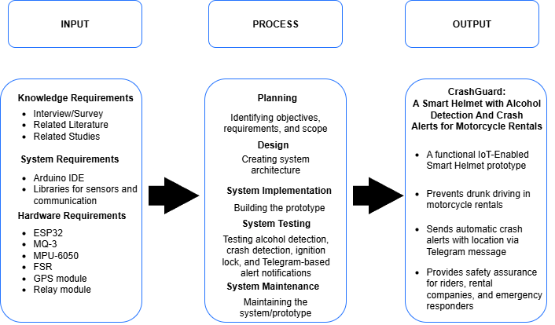

Figure 1: INPUT PROCESS OUTPUT
As stated in the diagram shown above, the components shown inside the box are the things necessarily needed for developing the IOT-Enabled Smart Helmet: The researchers will use hardware IOT components for the model, while for the process phase, waterfall methodology will be followed by the researchers. By maximizing the inputs in the process, the IOT-Enabled Smart Helmet will be developed. The helmet will encounter testing to ensure safety and functionality.
The development begins with a requirement analysis to identify what is needed for the system to meet its requirements such as alcohol detection, crash detection and ignition lock control. This is followed by a system design, which includes hardware and software planning to ensure a smooth flow in all the components.
Next, the hardware components such as the breath analyzer and the GPS modules will be carefully assembled into the helmet. The software will then undergo a developmental phase which involves coding and implementing the needed firmware for processing sensor data, detect alcohol levels and send SMS alerts.
Following the integration, testing will be conducted to ensure that the components work as intended, once initial testing is completed, the smart helmet will undergo real life testing to assess its performance and collect feedback.
The data gathered during each test will be analyzed to identify potential enhancements, enabling the researchers to enhance safety so that the smart helmet meets the required safety functionality standards before it is implemented in motorcycle rental businesses.

Definition of Terms

To provide help in clarifying the terms used in this study, the following will be defined according to their use in the study.

Internet of Things (IOT) – group or network of physical devices such as sensors and machines that are connected to the internet. They can collect and share information or data. These devices can be controlled remotely and operated individually.

Driving under influence (DUI) – driving a vehicle after consuming alcohol. This is considered as a criminal offense and can cause great risk in the street.

Blood Alcohol Concentration (BAC) – It refers to testing the amount of alcohol in a person's blood. It is mostly used for determining the legal intoxication level suitable for driving.

Short Messaging System (SMS) – Also known as text messaging is a service that allows an exchange of messages between two users, typically via the use of cellular network.

Wearable Technology – Electronic devices worn on the body (e.g., smartwatches, smart helmets) that collect and transmit valuable data.

Sensor Technology – Devices used to detect changes in the environment, such as alcohol sensors (MQ3), motion sensors(MPU 6050), and biometric sensors.

Ignition Lock Mechanism – A safety feature that prevents vehicle ignition to prevent the vehicle from starting

Machine Learning (ML) – the usage and development of computer system to be able to
adapt without following instructions and analyze patterns in data.

Artificial Intelligence (AI) – The simulation of human intelligence by machines to perform
tasks such as decision-making, detection, and prediction.

ESP32 - A low-cost and low-power microcontroller with built-in Wi-Fi and Bluetooth,
used as the main processing unit for IoT-based projects.

MQ-3 - An alcohol sensor module that detects the presence of alcohol in the breath and
outputs a corresponding analog signal, useful for sobriety tests.

MPU-6050 -A sensor module that combines a 3-axis gyroscope and a 3-axis accelerometer,
used for motion tracking, crash detection, and balance monitoring.

FSR (Force Sensitive Resistor) -A type of sensor that changes its resistance depending
on the force or pressure applied, often used to detect impacts.

GPS Module - A hardware device that provides real-time location data by receiving signals
from satellites, used for tracking and sending location details.

Relay Module - An electrically operated switch that controls circuits, allowing the system to activate or deactivate components.

Chapter II
Review of Related Literature
Related Literature

This chapter provides reviews about relevant studies that helps in the development of an IOT-Enabled smart helmet with alcohol detection, SMS alert, and ignition lock mechanism, With the increasing number of alcohol related accidents caused by driving under influence and lack of helmet usage, the incorporation of these features in a wearable gear will play a crucial part for safety technologies.

Integration of IOT in our daily lives
As a transformative force, IoT is redefining how we interact with the world by connecting everyday objects to the internet, enabling seamless data collection, exchange, and processing. According to Alzoubi & Alzoubi (2024) Internet of things (IoT), is a structure of correlated mechanical, computing and digital machines or devices, human or animal, objects which contributed with specific identities and the capability to transmit information through network without using human to computer or human to human interactivity. This technology is making environments smarter and more efficient, from smart homes that automatically adjust lighting and temperature based on user behavior to wearable health devices that monitor vital signs in real time (Rajini et al., 2025), this study illustrates how IOT drastically helped improve our daily lives by transforming devices into making them efficient.
The deployment of the IoT concept has had the overall impact of the improved quality of the products and services that organizations create [8]. It is now possible for organizations to preset the specific features and conditions of the products or services to be created and delivered in their systems of operations. It has autonomous machines execute such commands and deliver products that match the specific quality expected (Afifi et al., 2021). The increasing use of IOT-Enabled devices in industrial or commercial applications shows it’s potential to help improve the automation of data analysis and collection.
While the IoT concept is relatively not fully understood for some people, its continued applications are helping to improve the quality of life that many people across the world are using today. The developments revolving around the IoT concept are changing the way things are done and improving the applications of technology in the execution of activities and operations that were previously considered difficult (Afifi et al., 2021). For example, in healthcare devices that are wearable can alert doctors and patients when there is an abnormality in health indicators. On the other hand, in transportation, IOT-Enabled systems are used to track vehicles, monitor drivers and even send alerts whenever there is an accident happening.
These advanced technologies can such as automated response and real-time monitoring can be integrated into a personal protective gear. Additionally, the application of the IoT concept has enabled the simulation activities often undertaken to ensure that any tests required for any product or service yield the expected results before it is deployed in the market or for community use (Afifi et al., 2021).
Applying IOT into gears such as helmets can provide aid such as monitoring the behavior of the rider and preventing accidents, thus making the integration of IOT one of the vital elements of modern technology.

Role of Wearable Technology in Safety and Healthcare
Wearable technology became a pivotal part of modern safety and healthcare solution, providing continuous and real-time feedback to the users. Devices such as smartwatches and fitness trackers are now capable for monitoring important data such as heart rate, sleep patterns and even oxygen levels. According to Sharma et al., (2022), The devices are connected to gather data, monitor actions, and then tailor the experiences to meet the needs of the users depending on the obtained and recorded data. Agriculture, sports, and healthcare navigation systems are just a few of the industries where wearables may be found. Sensors, network connections, data processors, cameras, and other features are included in wearable gadgets.
Multiple parameters may be monitored and synced using this method. Wearables that are built for a certain use may include multi-sensor capabilities that are configurable for that application. Wearables must be designed to be comfortable to wear and lightweight while being modest in appearance and versatile. Sensing, analyzing, storing, communicating, and applying are the essential functions that wearables should fulfil. Data processing might take place either at the wearer's location or at a distant site. In safety applications wearable devices are sometimes used to detect accidents such as fall or any unusual movements, which can immediately send report to provide a faster and immediate response. The integration of wearable devices not only drastically improved the quality of life but also helps prevent potential issues by identifying its early signs. When applied for road safety, wearable devices like IOT-Enabled smart helmets offer an additional layer of protection by combining wellness monitoring with accident detection which enhances the safety of the riders and provides faster emergency response.

Effects of Alcohol Consumption in the body
There are many social stigmas associated with alcohol intake. Most people get into alcohol addiction by getting inspired to the people they admire, like actors, celebrities, role models, etc. Also, exposure to the sight of family members, relatives and friends drinking alcohol has a huge impact on one’s mindset as he or she may take it to be normal (Varghese & Dakhode 2022). Through the ages, alcoholism has been undisputedly maintaining its position in the list of risk factors for preventable diseases in the world.
According to a WHO report, 5.3% of all deaths that occurred worldwide in the year 2016 because of harmful alcohol use (Varghese & Dakhode, 2022). Consumption of alcoholic beverages have multiple effects on the body whether its short term or long-term depending on the frequency or the quantity of the alcoholic intake. Most of the time, along with the person who consumes alcohol, several other factors are also to be taken care of to effectively manage alcohol related health conditions. These factors can be social, environmental, genetic, psychological etc., which make a considerable impact on how alcohol affects the behavior and body of those consuming it (Varghese & Dakhode, 2022). In the short term, alcohol can impair cognitive function, coordination and even decision-making capabilities which can hinder in our productivity. As Blood Alcohol Concentration (BAC) increases the effects becomes more noticeable such as slurred speech, slowed reflexes, vomiting, nausea, and in some cases loss of consciousness.
Alcohol clearly plays a very important role in making many other diseases progress to their advanced stages. It has been also noted that alcohol intake and its related disorders are often associated with many other manifestations (Varghese & Dakhode, 2022). Over time excessive alcohol use can have serious consequences and opens more risks to our health such as liver disease like fatty liver, alcoholic hepatitis, fibrosis and cirrhosis. Additionally, long-term alcohol abuse can damage the cardiovascular system, weaken heart muscles and even contribute to blood pressure increase. As stated by (Varghese & Dakhode, 2022), Most of the patients diagnosed with pancreatitis have a strong history of chronic intake of alcohol.
Liver diseases related to alcohol intake are known to humankind from the very beginning and probably are one of the oldest known forms of injury to the liver [15]. In liver diseases linked with alcohol, liver cirrhosis is a major concern. This shows that excessive intake of alcohol leads to long term diseases that can be fatal if left untreated. Even the immune system will also be compromised in the long-term making the body more susceptible to infections and other diseases. (Varghese & Dakhode, 2022) also states that alcohol affects innate immunity and interferes with almost all the various aspects of the adaptive immune response. Alcohol is a key player in impairing anti-inflammatory cytokines and promotes proinflammatory immune responses. Furthermore, heavy alcohol consumption not only hinders us daily but also destroys our body making us vulnerable to health risks and diseases.

Impact of Alcohol Consumption on Road Safety

Consumption of alcohol heavily affects the road safety by hindering and impairing the driver’s ability to think and react clearly which can lead to not being able to maneuver the vehicle properly. Yadav and Velaga (2022), states that compared to the sober state, the increments in speed limit violations were 53%, 138% and 143% in rural driving environment, and 68%, 89%, 95% in urban driving environment at 0.03%, 0.05% and 0.08% BACs. While 0.03% and 0.05% BACs did not significantly influence the lane excursions in rural environment, 0.08% BAC resulted in 107% increment. Every year driving under the influence of alcohol remains as one of the if not the leading cause of road traffic accidents in the world.
Alcohol poses risks in the human body in the long term if there is an excessive intake, but this is only one of the risks it possesses. On the other hand, alcohol can also hinder a person from doing something due to intoxication. Specifically, for driving, it has been reported that alcohol could cause a delay in receiving perceptual information (perception), such as perceiving traffic signs or pedestrians, which then impairs cognition such as speed estimation, and action, such as maintaining a consistent speed (Yadav & Velaga, 2020). Despite legal sanctions in place, people continue to drive after drinking alcohol.
In fact, it was reported that drivers impaired by alcohol were responsible for 147 million oinstances of driving under the influence in 2018 (Centers for Disease Control and Prevention, 2020). According to Pešić et al., (2019) At night, DUI occurred more frequently in urban areas than in rural areas, 1.78 and 1.21%, respectively. During the day, DUI was more prevalent in urban areas (0.59%) than in rural areas (0.45%). At both testing locations DUI was more frequent at night.
According to Beaulieu et al., (2022), outcomes included motor vehicle crash injuries, deaths, or driver culpability; suspected driving under the influence.and simulated driving performance. Evidence from multiple sources showed a significant rise, approximately 1% to 7%, in the prevalence of opioids among fatally injured drivers in the U.S. from 1995 to 2016. Laws have been passed on every country to prevent riders from driving under the influence of alcohol but every year it seems like nothing is working, that’s why some checkpoints provide law enforcement officers with the necessary tools to perform sobriety tests on the
drivers.

Importance of faster response time

According to Yunus & Abdulkarim (2022), Because crashes are unavoidable, mitigating their consequences can be accomplished by systematically analyzing them and implementing appropriate solutions such as traffic control equipment, better road design, traffic regulation enforcement, and, most importantly, provisions for efficient emergency response and optimum access to emergency healthcare facilities. A fast response time to emergency or accidents is an important factor in reducing the injuries which can often lead to death. It also helps in avoiding any further accidents by clearing the road while reducing the risk for other drivers. Balfaqih et al., (2022), stated that the time after the traumatic injury is called golden hour, where providing essential medical and surgical aid at that time increases the probability of saving human lives by one-third on average [2]. Thus, significant efforts have been allocated in the recent past with the goal of providing efficient and prompt rescue operations. The Internet of Things (IoT) is one of the tools that has been utilized to achieve this goal, The author also states that the IoT was presented back in automobile industries to provide different information and entertainment applications with the aim of providing a comfortable driving experience and luxury journey. Recently, the IoT has been employed to increase the safety of drivers and passengers.
Several research works have presented IoT systems to detect, localize, report, model, and analyze road accidents. These models cam the provide feedback or warnings to help prevent accidents by monitoring the driving patterns such as braking and swerving. Additionally, AI algorithms in IOT-Enabled devices can be used to process and determine data to detect alcohol content and eve unusual driving activity, activating preventive mechanisms like ignition lock. The only downside of these systems according to Balfaqih et al., (2022) The main drawbacks of the existing accident detection systems are the high cost and limitation to high-end vehicles only. Most of these systems depend on a smartphone, and if it is ejected outside the vehicle, the system may fail and affect the results. Other than that, as time goes on the system learns to adapt making them more accurate and much more reliable in enhancing our safety on the road.
The reviewed literatures emphasize and show the importance of IOT Integration on our daily lives and shows the risks of alcohol consumption, while some studies have explored each of these topics individually, there is still a lack of systematic approach that provides a solution for this long existing dilemma. This study fills the void by proposing a smart helmet that implements helmet use, detects alcohol consumption, and sends an SMS alerts to designated contacts for faster response. The development of such a wearable safety device that serves as an approach to help mitigate the alcohol-related traffic incidents and enhance the safety rider’s safety.

System Technical Background

The project focuses on developing an IOT-Enabled smart helmet with alcohol detection, SMS alert, and Ignition lock mechanism. This project aims to provide a way to improve road safety by preventing driving under the influence of alcohol, detecting accidents and sending SMS alerts for faster response and automatically disabling the ignition system to prevent drunk drivers from starting the vehicle. By incorporating Internet of Things (IOT) technology, the system establishes a smooth connection between the smart helmet, alcohol detector, SMS alert system, and vehicle ignition, providing an effective approach for the safety of the rider and provide and faster emergency response.
The Internet of Things (IOT) enables the device connected to gather, process and trade data over a network, creating a system that can respond to real-time conditions in the real world. The IOT components play a crucial role in assessing and tracking the rider’s environment and data. As accidents involving riders continues to rise, especially that alcohol related or delayed response from the authorities, this system proposes an innovative solution for a timely problem.
The smart helmet is equipped with multiple sensors with different use to fulfill its main functions. A sensor like MQ-3 is used to detect the presence of alcohol in the breath, Once the rider wears the helmet, the sensor then collects the data and sends it into a microcontroller for data processing. If alcohol level exceeds the safe threshold, the system immediately alerts the system and activates the ignition lock, preventing the start-up mechanism of the vehicle to prevent them from driving under the influence of alcohol.
To address scenarios where in accident happens, the helmet incorporates an MPU 6050 sensor, which combines a gyroscope sensor with an accelerometer to analyze and detect sudden impacts or unusual movement by the vehicle, when a crash is determined, the system triggers and sends an emergency alert notifying the registered contacts to send immediate help. The alert may also include a real time location through the help of GPS module, allowing for emergency respondents to get to the location quickly.
A relay module serves as an ignition lock mechanism, managing the power flow of the connected vehicles ignition system. The relay is managed by an ESP8266 microcontroller, which translates the sensors data and executes the command. The ESP8266 is handpicked due to its powerful capabilities and its features such as built-in WI-FI connectivity that allows it to serve as the main systems central hub.
In summary, this helmet combines built in systems and IOT technology to make an intelligent solution and safety gear for riders, it not only prevents riders from drunk driving but also improves the emergency response due to its automated alert system. This smart helmet is expected to decrease the number of alcohol related accidents on the road and promotes responsible driving which can help save lives on the road.

Chapter III
Methodology of the Study

This chapter presents the methodologies used in the development of Smart Helmet. It specifies the design, processes and methods used for the accuracy and reliability of the system. This chapter discusses the research design, requirements and the development procedures used in creating and testing the system prototype. It also explains the techniques and instruments utilized to check the effectiveness and the overall functionality of the given system.

Research Methodology

This research adopted a developmental research design, which is appropriate since it focuses on systematic designs and evaluation to focus on a specific issue which in this case is the rapidly increasing number of road accidents related to driving under the influence. The main purpose of this study is to create an IOT-Enabled Smart Helmet that has features like Alcohol detection, Crash Sensor, SMS Alert System and Ignition Lock Mechanism. With the current surging number of alcohol-related accidents the risk posed by driving under influence has skyrocketed, to attain this, the researchers used developmental research method which focuses on the creation and improvement of the product and the development of a functional prototype to identify the possible lapses and analyze the needed information for the creation of the smart helmet.
This research used quantitative research in data gathering, it is used in gathering the measurable data from the sensors such as the BAC level to see the overall effectiveness of the helmet to further improve it for the future users.

Software Development Methodology

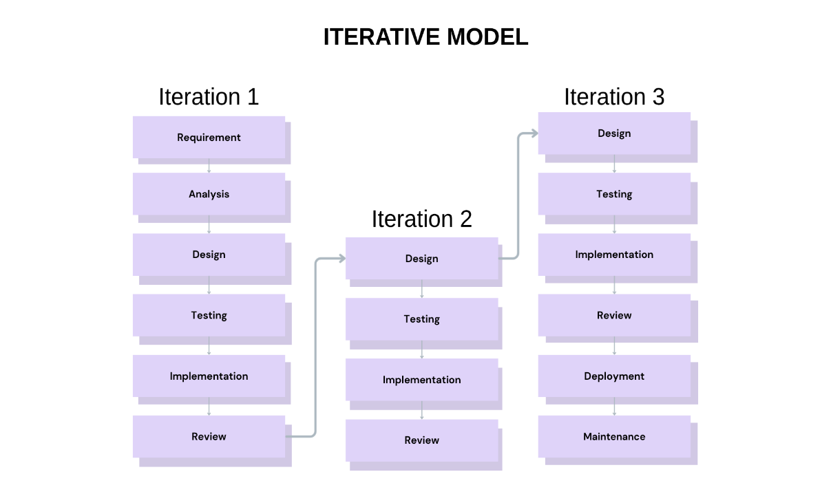

Figure 2: Iterative Model

The researchers adopted the Iterative Model as the software development approach for this study. As shown in Figure 2, the model consists of multiple repeated cycles, each called an iteration where the system is gradually designed, implemented, tested, and refined. Unlike linear models, the Iterative Model allows flexibility and continuous improvement, which is necessary for a hardware-based prototype that requires repeated calibration such as alcohol detection, crash sensing, GPS location retrieval, and ignition control.
In Iteration 1, the team focused on defining requirements, conducting analysis, designing the initial architecture, implementing the first prototype, and evaluating its functionality.
Iteration 2 refined the design based on initial issues encountered, followed by further testing, improved implementation, and additional review.
Finally, Iteration 3 applied advanced refinements, including integration of all major features, further testing, prototype deployment for real-world conditions, and planning for maintenance.
This cyclical structure enabled the researchers to address issues early, incorporate feedback from alpha and beta testers, and achieve higher accuracy, reliability, and performance in the final prototype.

Requirements Analysis and Documentation
Functional Requirements
Alcohol Detection – The helmet should detect the presence of alcohol through the breath sensor that is in the helmet. If the amount of alcohol present exceeds the threshold, then the motorcycle ignition should be locked preventing them from driving.
Crash Detection and Alert System – The helmet includes MPU 6050 that includes a built-in accelerometer and gyroscope which will be used to detect accidents. Upon detection, the helmet will send SMS alerts to the assigned emergency contact for faster emergency response.
Ignition Lock Mechanism – The motorcycle would only start and run if the smart helmet is worn and the sobriety test was passed.

Non-Functional Requirements
Reliability – The helmet’s features must work accurately and continuously under any disturbance or circumstance.
Scalability – The helmet should be able to handle the process of each of its features.

System Requirements
Helmet
Alcohol sensor (e.g., MQ-3)
Accelerometer/Gyroscope (e.g., MPU6050)
Microcontroller (e.g., ESP32)
Relay module for ignition lock
Rechargeable battery pack

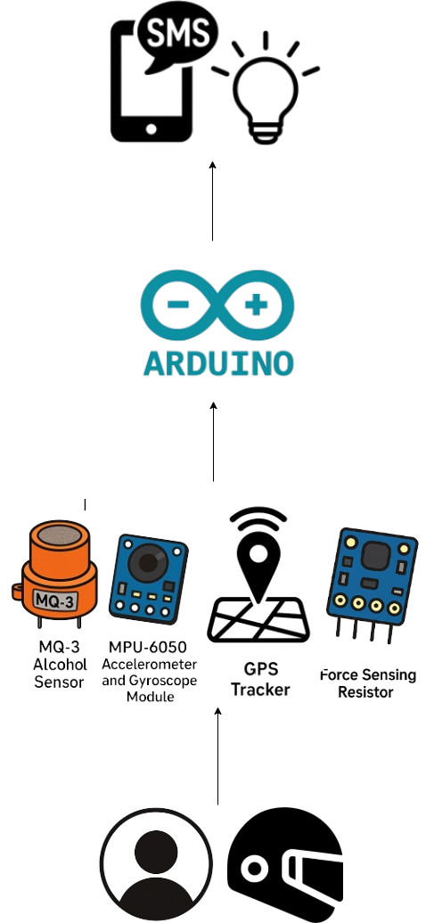
WORKPLAN

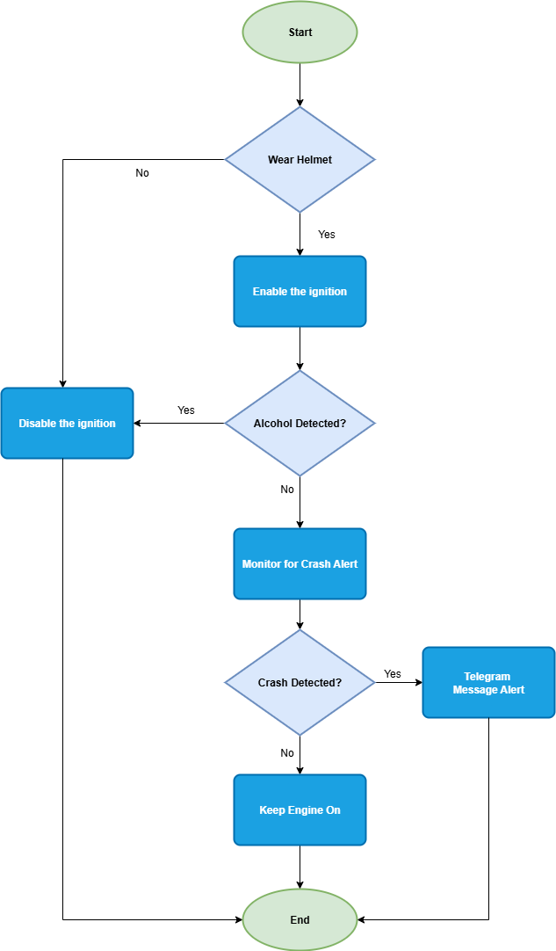
FLOWCHART

Figure 3: System Flowchart Design

Figure 3 illustrates the flow of the system. The process starts with a system initialization to verify whether the rider is wearing the helmet or not. If the helmet is not detected, then it immediately disables the vehicles ignition making it impossible to start. If the helmet was detected, then the helmet conducts alcohol detection using the sensors. If the BAC exceeds the acceptable threshold, then it will automatically trigger the vehicle ignition to be disabled to prevent drunk driving, but if no alcohol is detected then the ignition will be enabled. Once the vehicle is in use the sensors will continuously check and monitors the rider and the vehicle for possible accidents through the help of the accelerometer and gyroscope. If an accident is detected then it will automatically send SMS alerts to pre-defined emergency contacts, but if there are no accidents happened then the cycle ends without further actions. This cycle makes sure that the rider will only operate under safe conditions prioritizing its safety and avoiding any accidents

Block Diagram
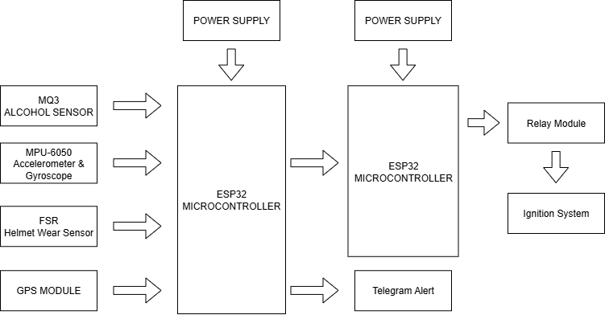

Figure 4: Block Diagram
The system is designed to check two predefined conditions before allowing engine ignition. The first condition checks if the rider is wearing the helmet through the FSR sensor, while the second condition detects alcohol in the rider’s breath using the MQ-3 sensor. The ESP32 processes these inputs and controls the relay module to enable or disable the motorcycle.

In the event of an accident, the MPU-6050 is used to detect the impact and a short message service with location details from the Neo-6M GPS module will be automatically sent to Telegram.

Circuit Diagram
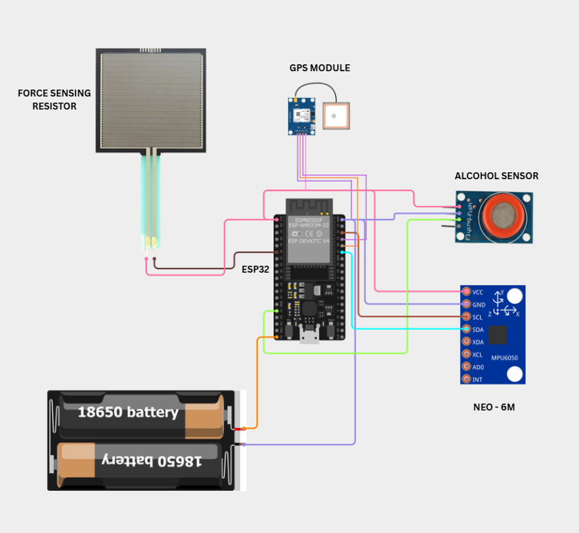

Figure 5: Helmet Circuit Diagram

Figure 5 illustrates the circuit diagram of the Helmet Unit, centered on an ESP32 microcontroller that serves as the main controller of the system. The diagram shows how the sensors and modules are electrically connected to the ESP32 for data acquisition and processing.
The Force Sensing Resistor (FSR) is connected to the ESP32 to detect pressure, which is used to determine whether the helmet is being worn. The MQ-3 alcohol sensor is interfaced with the ESP32 to monitor alcohol presence in the rider’s breath by providing analog sensor readings.
An MPU-6050 accelerometer and gyroscope is connected via the I2C communication pins of the ESP32 to measure motion, orientation, and sudden impacts for accident detection. The NEO-6M GPS module is also interfaced with the ESP32 to supply real-time location data in terms of latitude and longitude.
Power to the entire helmet unit is supplied by a 18650 lithium-ion battery, which is connected to the ESP32 to ensure portable operation. This circuit diagram highlights the electrical connections and integration of all helmet-mounted components used for sensing, monitoring, and data collection.
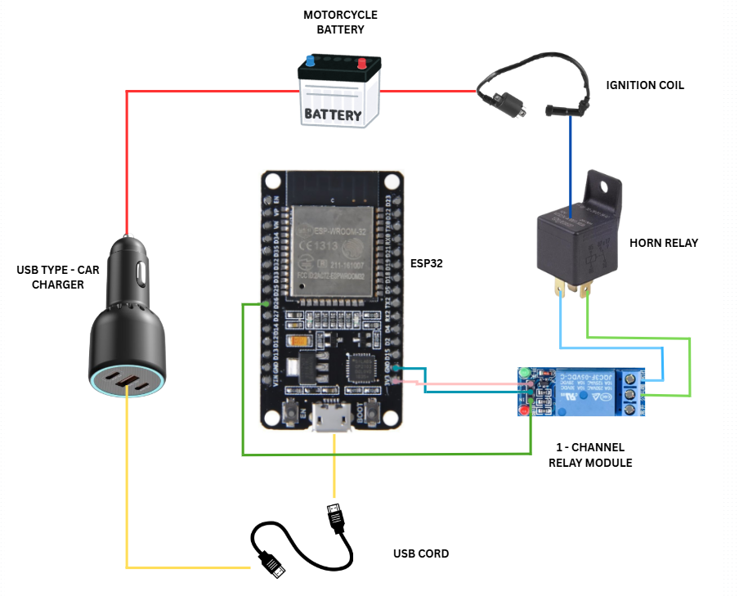
Figure 6: Motorcycle Circuit Diagram

The figure 6 illustrates of the ESP32 microcontroller and the relay module for the control of the motorcycle ignition system is depicted in the diagram. The relay module is an electronic switch that turns off or turns on the power connection for the ignition circuit as stated to the states that the system detects.

With this arrangement, the VCC pin of the relay board is tied to the 3.3V/5V output from the ESP32 for the necessary operating power, and the GND pin is tied to the ground (GND) of the ESP32 for circuit closure. In addition, the IN pin of the relay is tied to one of the ESP32 digital output pins, and hence, the state of the relay is controlled from the microcontroller based on programmed instructions.

When all safety conditions—that is, helmet detection and alcohol verification—are satisfied, the ESP32 generates a HIGH output to the relay module and therefore enables the start of the ignition of the motorcycle. When unsafe conditions exist, the relay is OFF, and the engine will not turn on.

Research Tools and Instruments

The type of sampling method that will be utilized in this study is purposive sampling, The chosen participants by the researchers are those who own a motorbike rental company and motorcycle riders. By employing this sampling, the data that will be collected will be used to analyze and showcase the result in methodological approach.

Respondents of the Study

In determining the number of participants needed for this research, the researchers used the Raosoft online sample size calculator to ensure that the results gathered would be statistically reliable. The calculator was configured with a 5% margin of error and a 95% confidence level, using a population size relevant to motorcycle rental owners and motorcycle riders. With a 50% response distribution, the recommended sample size generated was 109 respondents.

These respondents represent individuals involved in motorcycle rentals and active motorcycle riders, making them suitable participants for evaluating the CrashGuard Smart Helmet. Their insights provided valuable feedback on safety features, usability, and real-world applicability of the system.
Table 1. Sample Size Distribution using Raosoft Calculator
Margin of Error | 5%
Confidence Level | 95%
Population Size | 150
What is the response distribution | 50%
Recommended Sample Size | 109

Instrument of the Study
The primary research instrument utilized in this study is a structured questionnaire developed to gather relevant data, observations, and feedback regarding the performance and acceptability of the CrashGuard Smart Helmet. This instrument was created to assess the effectiveness of the system’s core features alcohol detection, crash alert, GPS location tracking, and ignition lock mechanism from the perspective of motorcycle rental owners, riders, and expert evaluators.
The questionnaire was patterned after the ISO/IEC 25010 Software Quality Model, which guided the evaluation across several quality characteristics, including Functionality, Reliability, Usability, Efficiency, Security, and Maintainability. Each indicator within these categories was rated using a 5-point Likert scale, allowing respondents to express their level of agreement based on the following scale:
Table 2. Likert Scale Value
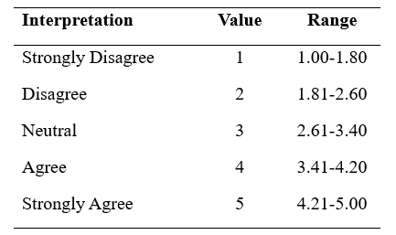
This format ensured that the collected data would be quantifiable, organized, and suitable for statistical analysis.

To further supplement the quantitative results, the researchers also conducted interviews with selected participants to gather additional insights, real-life experiences, and detailed feedback regarding the smart helmet’s design and usability. These interviews provided valuable observations that supported the refinement and validation of the prototype.
For wider accessibility and efficient distribution, the questionnaire was also converted into a Google Form. This allowed respondents to conveniently answer the survey while ensuring systematic data collection.
Before administering the instrument, the researchers formally sought approval through letters addressed to the identified respondents. Once granted and endorsed by the capstone adviser, the questionnaires were distributed. Throughout the data-gathering phase, the researchers personally facilitated the process to address any concerns or clarifications raised by the respondents, ensuring the accuracy and reliability of the collected information.

ISO/IEC 25010 Software Quality Model
The evaluation of the CrashGuard Smart Helmet aims to assess its performance, accuracy, safety, and overall user experience in detecting alcohol, monitoring crashes, sending automated alerts, and providing ignition lock control. To ensure that the system is well-developed, functional, and reliable, the researchers used the ISO/IEC 25010 Software Quality Model as the main framework for assessing the quality of the smart helmet.

ISO/IEC 25010 is an internationally recognized standard used in evaluating system and software quality. It defines several quality characteristics that guide developers in determining whether a system meets its intended requirements. For this capstone project, the researchers selected six of the model’s key quality characteristics Functionality, Reliability, Usability, Efficiency, Security, and Maintainability as the primary basis for evaluating the CrashGuard Smart Helmet through a 5-point Likert scale.

Functionality evaluates the accuracy and correctness of the smart helmet’s core features. This includes the MQ-3 alcohol sensor, MPU-6050 crash detection module, GPS tracker, helmet detection (FSR), and the ignition lock mechanism controlled by the ESP32 microcontroller. This criterion ensures that the system performs its intended tasks effectively—detecting alcohol accurately, identifying crash events, retrieving GPS location, and preventing unauthorized ignition.

Reliability measures the consistency and dependability of the system. It examines whether the smart helmet can operate smoothly during repeated tests, send alerts without fail, maintain sensor accuracy, and function without unexpected errors. This includes evaluating the system’s stability during long-duration use and its resilience under different environmental conditions.

Usability focuses on the ease of use and comfort of the smart helmet. Even with added components, the helmet must remain comfortable to wear and simple to operate. Users should find it easy to understand system alerts, interpret messages, and follow the required procedures for helmet detection and alcohol testing. This ensures a positive user experience for both casual riders and rental company operators.
Efficiency evaluates the responsiveness and performance of the system. This includes how quickly the sensors detect alcohol levels or crash events, how fast the GPS retrieves location data, and how efficiently the microcontroller processes sensor inputs. It also considers power consumption and the system’s ability to minimize false alerts.

Security assesses how well the system ensures rider safety and protects the electrical integrity of its components. This includes checking whether the wiring is properly insulated, the ignition cut-off is safely implemented, and the system does not interfere with the normal and safe operation of the motorcycle. It also considers the reliability of transmitting alert messages and sensitive information such as GPS location.

Maintainability focuses on the system’s ability to be repaired, updated, or modified when needed. This includes evaluating the accessibility of internal wiring, ease of component replacement, clarity of the program structure, and the secure mounting of sensors. A maintainable design ensures that the smart helmet can be serviced or improved for future use.

By evaluating the CrashGuard system under ISO/IEC 25010, the researchers ensured that the smart helmet meets essential quality standards in terms of performance, user safety, dependability, and long-term usability. This structured assessment provides a comprehensive measure of the system’s effectiveness and validates its readiness for real-world application.

Statistical Analysis of Data
The respondents of the study were carefully selected based on their experience in motorcycle riding, involvement in motorcycle rental operations, and familiarity with evaluating safety-related systems. The survey questionnaire was given to these targeted participants, which included motorcycle riders, motorcycle rental owners, and alpha testers who provided technical feedback. Their input was important in assessing the overall performance, usability, and reliability of the CrashGuard Smart Helmet. From this group, the researchers identified a total population of 150 individuals, which served as the basis for computing the required sample size.
Table 3: Number of Respondents of Crash Guard: A Smart Helmet with Alcohol Detection and Crash Alert for Motorcycle Rentals
Respondents | No. of Respondents
Motorcycle Riders | 102
Motorcycle Rentals | 4
Alpha Tester | 3
Total | 109

$Formula n=\frac{N}{(1+Ne^{2})}$
Whereas n = Number of Sample
N = Total of Population
E = Margin of Error
Given:
N = 150
e = 5% or .05
Solution:
$Formula n=\frac{150}{1+150{(0.05)}^{2}}$

$n=\frac{150}{1+150(0.0025)}$

$n=\frac{150}{1+0.375}$
$n=\frac{150}{1.375}$

$n=109.091$ or 109

To determine the total number of respondents needed for the study, the researchers used Slovin’s Formula. This formula determines the appropriate sample size by dividing the population by 1 plus the population multiplied by the square of the margin of error. Using this computation, the researchers determined that the required sample size for the study was 109 respondents.

All data collected from the respondents and measured using a 5-point Likert scale were used to evaluate the system based on the ISO or IEC 25010 quality characteristics. The answers played an important role in improving the prototype, refining its features, and identifying areas that needed further development. Through this method, the researchers ensured that the evaluation of the CrashGuard Smart Helmet was accurate, complete, and focused on the needs of the users.
Formula: WM = Σ(wv)/ N
Where WM = Weighted Mean
w = Frequency
v = Numerical values
Σ(wv) = Sum of the product of each value and its frequency
N = Total number of respondents

Implementation Plan

The researcher conducted a survey in which the prepared questionnaires are carried out via face-to-face approach using the Likert scale. The questionnaire was created to gather feedback based on ISO25010; the gathered data will be used to enhance the proposed system and widen the knowledge of the researchers to provide a seamless creation of the output.
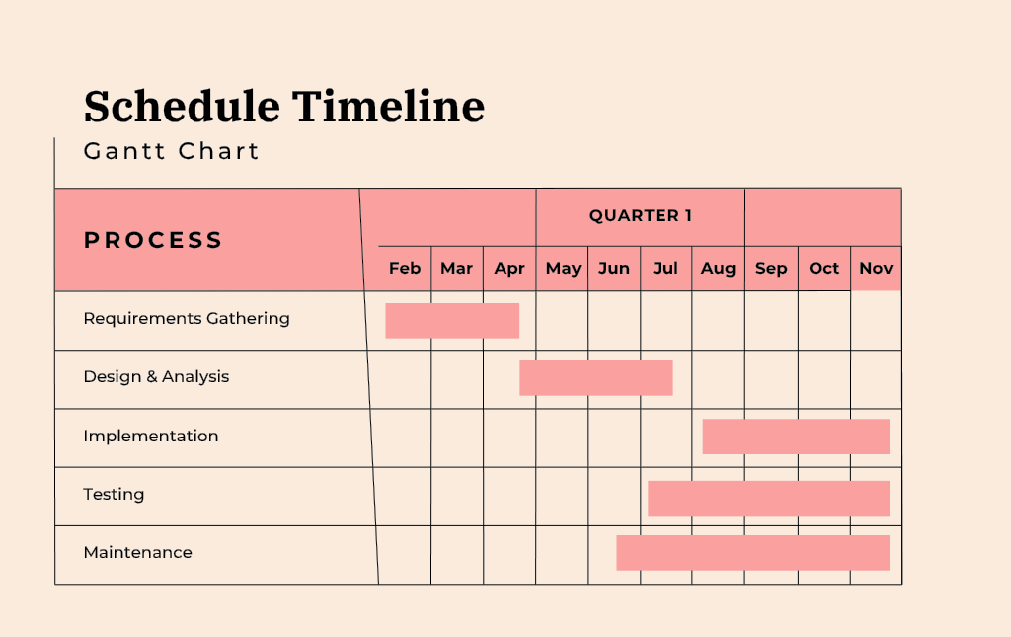

Figure 7: Schedule Timeline
Figure 7 shows the time span from February 2025 up to November 2025 that
proponents consumed in development of the project.

CHAPTER IV

Results and Discussion

This section presents the results and the summary that corresponds to the goals and objectives set by the researchers. The main goal of this study is to create a smart helmet with features like Alcohol detection, Crash alert system, Ignition lock Mechanism and GPS to help reduce the risks of alcohol related incidents.

Objective 1 – Alcohol Detection System Performance: The Crash Guard has successfully achieved its first objective, which is to develop an alcohol detection system that prohibits the motorcycle from starting if the BAC% of the rider exceeds the certain threshold set by the researchers in line with the LTO guidelines. This feature allows the riders to avoid driving under the influence of alcohol minimizing the risks of alcohol related accidents.

Objective 2- Helmet Detection Feature: The second objective is successfully achieved by integrating a feature that detects whether the helmet is worn properly to promote safety and proper usage of safety gears. This functionality confirms that the helmet detection feature is working and effectively administers helmet usage and prevents unauthorized rides.

Objective 3- Accident Detection and Emergency Alert Functionality: The helmet accomplishes the third objective, which is Accident Detection. When an accident occurs, the helmet sends a notification with real-time GPS location via SMS using the telegram application. In addition, complete detection occurs within 3-5 seconds depending on the location ensuring a fast emergency response.

Objective 4- System Performance and Reliability: Upon further testing the systems worked without any significant delays, miscalculations or misreadings. These results shows that the smart helmet meets the required functional safety and can perform excellently in real world conditions, satisfying Objective 4.

Objective 5- User Acceptance and Feasibility: Participant stated that the smart helmet added an extra sense of safety especially in rental environment because the riders activity cannot be monitored directly. Some operators also express strong interest in deploying the system due to its potential to prevent and reduce any alcohol related accidents and enforce responsible riding practices. These results confirms that the smart helmet is feasible and accepted by both rental companies and riders, achieving Objective 5.

Pre-Survey Results

The researchers conducted a pre-survey for rental owners and motorcycle riders to gather suggestions and feedback. The responses will help the researchers in improving and gathering data to ensure it meets the needs of both the riders and rental business owners. This will help
with the development of Crash Guard: A Smart Helmet with Alcohol Detection and Crash Alert for Motorcycle Rentals.

Table 4 : Responses of the Participants in the Pre-Survey Questionnaire of Crash Guard: A Smart Helmet with Alcohol Detection and Crash Alert for Motorcycle Rentals.

Questionnaires | Mean | Description  Rating
1.The smart helmet’s features (alcohol detection, crash alert, GPS) are useful and relevant for rider safety | 4.02 | Strongly Agree
2. I believe the system would operate consistently without frequent errors or failures. | 3.56 | Strongly Agree
3. The smart helmet would be easy to use and understand, even for non-technical users. | 3.87 | Strongly Agree
4. The system’s sensors and alerts would respond quickly and accurately during emergencies. | 3.87 | Strongly Agree
5. I trust the helmet to protect user data (e.g., GPS location, alcohol level) from unauthorized access. | 3.84 | Strongly Agree
6. I believe the system can be easily updated, repaired, or recalibrated when needed. | 3.80 | Strongly Agree
7. I believe the system can be easily updated, repaired, or recalibrated when needed. | 4.07 | Strongly Agree
8. The alcohol detection feature can effectively prevent riders from driving under the influence. | 3.93 | Strongly Agree
9. The crash alert system would significantly reduce the time for emergency response. | 3.96 | Strongly Agree
10. I believe the helmet’s sensors and alarms will function correctly even in extreme conditions (rain, heat, vibration). | 3.82 | Strongly Agree
11.I would feel safer using or renting a motorcycle equipped with this smart helmet. | 3.85 | Strongly Agree
12. The system should alert or shut down safely in case of malfunction or sensor failure. | 3.91 | Strongly Agree

The result of the questionnaire shows a positive view towards Crash Guard, with all the questions ranging from 3.56 to 4.07, labeling them as “Strongly Agree”. Respondents show confidence that the helmet can provide extra layer of safety. Additionally, the results shows that there is willingness to try and experience the Crash Guard showing there is a positive overview on the effectiveness of the smart helmet.

Table 5: Assessment of the Respondents on the Functionality of the Smart Helmet.

Functionality | No. of respondents | SA (5) | A (4) | N (3) | D  (2) | VD  (1) | TOTAL | WM
The system accurately detects alcohol levels through the MQ-3 sensor. | 109 | 102  (504) | 7  (27) | 0  (0) | 0  (0) | 0  (0) | 538 | 4.94
The crash detection feature works reliably using the MPU-6050 sensor. | 109 | 92  (460) | 14  (56) | 3  (9) | 0  (0) | 0  (0) | 525 | 4.82
The GPS module (Neo-6M) provides accurate location tracking during a crash. | 109 | 85  (425) | 23  (92) | 1  (3) | 0  (0) | 0  (0) | 520 | 4.77
The relay mechanism properly controls the motorcycle’s ignition system. | 109 | 89  (445) | 16  (64) | 4  (12) | 0  (0) | 0  (0) | 521 | 4.78
The system performs all intended functions without major errors. | 109 | 84  (420) | 20  (80) | 5  (15) | 0  (0) | 0  (0) | 515 | 472
Average WM |  |  |  |  |  |  |  | 4.81

The survey results show that respondents strongly agree that the system performs all its intended features effectively and consistently. Core functions including alcohol detection, crash detection, GPS tracking, and ignition control were rated highly accurate and extremely reliable. The average mean of 4.81 indicates that the system performs exceptionally well and operates without major errors, confirming its strong functional performance.

Table 6: Assessment of the Respondents on the Realibility of the Smart Helmet

Reliability | No. of respondents | SA (5) | A (4) | N (3) | D  (2) | VD  (1) | TOTAL | WM
The system operates consistently under normal conditions. | 109 | 85  (425) | 23  (92) | 1  (3) | 0  (0) | 0  (0) | 520 | 4.77
The Telegram alert message is always sent and received successfully. | 109 | 81  (405) | 24  (96) | 4  (12) | 0  (0) | 0  (0) | 513 | 4.71
The sensors maintain accuracy even after repeated testing. | 109 | 81  (405) | 26  (104) | 2  (6) | 0  (0) | 0  (0) | 515 | 4.72
The system remains operational for a reasonable duration without resetting or crashing. | 109 | 82  (410) | 22  (88) | 5  (15) | 0  (0) | 0  (0) | 513 | 4.71
Average WM |  |  |  |  |  |  |  | 4.73

Based on the average mean of 4.73, respondents strongly agree that the system is reliable. It showed consistent operation under normal conditions, stable sensor accuracy after repeated testing, and dependable SMS alerts. Additionally, the system maintains stable performance without unexpected shutdowns. These results confirms that the system consistently provides reliable operation over time.
Table 7: Assessment of the Respondents on the Usability of the Smart Helmet.

Usability | No. of respondents | SA (5) | A (4) | N (3) | D  (2) | VD  (1) | TOTAL | WM
The system is easy to set up and operate. | 109 | 81  (405) | 24  (96) | 3  (9) | 1  (2) | 0  (0) | 512 | 4.69
The helmet’s modifications do not interfere with comfort and usability. | 109 | 82  (410) | 21  (84) | 5  (15) | 1  (2) | 0  (0) | 511 | 4.69
The crash and alcohol alerts are understandable to the user. | 109 | 83  (415) | 24  (96) | 0  (0) | 2  (4) | 0  (0) | 515 | 4.72
Overall, the system is user  friendly and convenient for motorcycle riders. | 109 | 79  (395) | 25  (100) | 5  (15) | 0  (0) | 0  (0) | 510 | 4.6
Average WM |  |  |  |  |  |  |  | 4.70

Survey results in usability findings show that respondents strongly agree, with an average mean of 4.70, that the system is easy to set up and use. The helmet modifications do not hinder comfort, and safety alerts are clear and easy to understand. These results shows that the system is user-friendly, and practical for everyday use among motorcycle riders.
Table 8: Assessment of the Respondents on the Efficiency of the Smart Helmet.

Efficiency | No. of respondents | SA (5) | A (4) | N (3) | D  (2) | VD  (1) | TOTAL | WM
The system responds quickly when detecting alcohol or crash events. | 109 | 90  (450) | 13  (52) | 5  (15) | 1  (2) | 0  (0) | 519 | 4.76
Power consumption is appropriate for its intended portable use. | 109 | 79  (395) | 21  (84) | 9  (27) | 0  (0) | 0  (0) | 506 | 4.64
The system minimizes false detections or unnecessary alerts. | 109 | 74  (370) | 31  (124) | 4  (12) | 0  (0) | 0  (0) | 506 | 4.64
The sensors and microcontroller work together without noticeable delay. | 109 | 77  (385) | 23  (92) | 9  (27 | 0  (0) | 0  (0) | 504 | 4.62
Average WM |  |  |  |  |  |  |  | 4.67

With an average mean of 4.67, respondents strongly agree that the system is efficient in its performance. The system reacts quickly to both alcohol detection and crash events, uses power appropriately, and minimizes false readings for alerts. Additionally, the interaction between sensors and microcontroller is seamless and delay free. These results indicate strong operational efficiency which provides extreme satisfaction.

Table 9: Assessment of the Respondents on the Security of the Smart Helmet.

Security | No. of respondents | SA (5) | A (4) | N (3) | D  (2) | VD  (1) | TOTAL | WM
The system does not interfere with the safe operation of the motorcycle. | 109 | 90  (450) | 14  (56) | 5  (15) | 0  (0) | 0  (0) | 521 | 4.78
The electrical components are properly insulated and safe from short circuits. | 109 | 72  (360) | 31  (124) | 5  (15) | 1  (2) | 0  (0) | 501 | 4.60
The helmet design ensures user protection even after system integration. | 109 | 84  (420) | 20  (80) | 5  (15) | 0  (0) | 0  (0) | 515 | 4.72
The system safely cuts off the ignition when alcohol is detected. | 109 | 85  (425) | 23  (92) | 2  (6) | 0  (0) | 0  (0) | 523 | 4.80
The GPS alert helps in quick response during emergencies. | 109 | 83  (415) | 24  (96) | 2  (6) | 0  (0) | 0  (0) | 517 | 5.74
Average WM |  |  |  |  |  |  |  | 4.73

Security survey results reflect strong agreement, supported by an average mean of 4.73. Respondents believe the system does not interfere with motorcycle safety and that all electrical components are securely insulated and safe. The helmet remains protective and working despite modifications, and security features such as ignition cutoff and GPS emergency alerts works effectively.

Table 10: Assessment of the Respondents on the Maintainability of the Smart Helmet.

Maintainability | No. of respondents | SA (5) | A (4) | N (3) | D  (2) | VD  (1) | TOTAL | WM
The system’s wiring and connections are easy to inspect or repair. | 109 | 81  (405) | 22  (88) | 5  (15) | 1  (2) | 0  (0) | 510 | 4.68
The code and setup are easy to update or modify if needed. | 109 | 84  (420) | 17  (68) | 6  (18) | 2  (4) | 0  (0) | 510 | 4.68
Replacement of components can be done easily without special tools. | 109 | 74  (370) | 27  (108) | 5  (15) | 3  (6) | 0  (0) | 499 | 4.58
The sensors and modules are mounted securely to prevent frequent maintenance. | 109 | 85  (425) | 19  (76) | 4  (12) | 1  (2) | 0  (0) | 515 | 4.72
The design allows for long-term use and reliability. | 109 | 85  (425) | 19  (76) | 5  (15) | 0  (0) | 0  (0) | 516 | 4.73
Average WM |  |  |  |  |  |  |  | 4.68

For maintainability part , respondents strongly agree, as shown by the average mean of 4.68, this shows the system is easy to inspect, update and repair if needed. Wiring and connections are accessible, the code is simple to edit, and components can be replaced without the need for special tools. Secure mounting of sensors reduces maintenance needs, supporting long-term usability.

CHAPTER V

SUMMARY

The respondents have given CrashGuard a Highly Acceptable rating for its features based on the evaluation of the system. With the aid of CrashGuard, motorcycle rental owners can avoid any alcohol related accidents which can cause damage to their properties. The ISO 25010 was used to describe the outcomes based on the analysis presented.

- Functional Stability
CrashGuard’s Functional Stability scored 4.81, showing that the users
gave the smart helmet a rating of Highly Acceptable. This score shows that the system meets the users’ needs effectively and exhibits a high level of performance while making sure that all the features are properly working.

- Reliability
CrashGuard received a score of 4.73 for reliability, showing they found the system to be Highly Acceptable. This score highlights the system's stability and reliability without significant errors while successfully meeting the user expectations.

- Usability
The users rated CrashGuard’s Usability a score of 4.70, indicating that users considered the system as Highly Acceptable. This shows that the smart helmet is easy to use and it meets the users' expectations for a hassle-free navigation that enhances the overall user experience.

- Performance Efficiency
CrashGuard’s performance efficiency received a score of 4.67, showing that users rated the system as Highly Acceptable. This suggests that the system works efficiently without experiencing major drawbacks or issues.
- Security
CrashGuard received a score of 4.73 for security, stating that the users considered the system to be Highly Acceptable. This shows the system's ability to protect the user while reassuring the users of its protection is working without any errors.

- Maintainability
The users gave CrashGuard’s maintainability a score of 4.68 showing they considered the system to be Highly Acceptable. This indicates that the system is easy to maintain and can be updated easily and effectively over time.

Conclusion
The outcomes of the study shows that the smart helmet successfully meets the required standards hence achieving the system’s objectives. Experts in Information Technology have rigorously checked the system's features confirming its accuracy and performance in achieving the system's goals. Responses from several different participants, including beta testers such as motorcycle riders and motorcycle rental owners, and even the IT professionals involved in alpha testing featured the system's functionality, usability, and overall performance. The development and execution of the smart helmet are further supported by the Grand Mean, which presents as a weighted average over the assessment criteria acting as a quantitative measure of contributor satisfaction and consensus with the study.
CrashGuard fully complies with the ISO 25010 standard, showcasing good scores among its key attributes. It received scores of 4.81 for Functional Suitability, 4.73 for Reliability, 4.70 for Usability, 4.67 for Efficiency, 4.73 for Security, and 4.68 for Maintainability, all of which are considered as Highly Acceptable. With an overall score of 4.72 the smart helmet is categorized as Highly Acceptable, showcasing a high level of quality and functionality that meets the standard’s qualifications.

Recommendations
The researchers acquired and analyzed the evaluation results using the ISO 25010 software’s quality model. The results showed that every feature of CrashGuard has fulfilled the system’s standards. Moreover, it shows that the system is now ready for deployment to the motorcycle rental shops in Pampanga.

REFERENCES
[1] Waluyo, T. A., Irawan, M. Z., & Dewanti, N. (2022). Adopting Electric Motorcycles for Ride-Hailing Services: Influential Factors from Driver’s Perspective. Sustainability, 14(19), 11891.
Retrieved from: https://doi.org/10.3390/su141911891
[2]Lu, J. L., Herbosa, T. J., & Lu, S. F. (2022). The effect of suspected alcohol intoxication on fatality and injuries of road users in Metro Manila — 2005-2020. Acta Medica Philippina, 56(19).
Retrieved from https://doi.org/10.47895/amp.v56i19.6277
[3]Maheswari, K., Madhumitha, U., Madhusurya, S., & Divya, T. (2020). Alcohol consumption detection using smart Helmet system. International Journal of Scientific Research in Science Engineering and Technology, 167–173.
Retrieved from https://doi.org/10.32628/ijsrset207244
Alzoubi, A. A., & Alzoubi, H. M. (2024). Investigating benefits of using IoT and its effect on our daily life. In Studies in big data (pp. 369–380). Retrieved from https://doi.org/10.1007/978-3-031-55221-2_25
[4] Rajini et al., (2025), IoT DEVICES AND THEIR INTEGRATION INTO DAILY LIFE
Retrieved from https://www.researchgate.net/profile/Joyanto-Roychoudhary/publication/389660477_Emerging_Research_Trends_in_Computer_Science_and_Information_Technology_ISBN_978-93-48620-71-2/links/67cbc88bcc055043ce6f45eb/Emerging-Research-Trends-in-Computer-Science-and-Information-Technology-ISBN-978-93-48620-71-2.pdf#page=22
Afifi, M. a. M., Ghazal, T. M., & Kalra, D. (2021). The impact of deploying the internet of things and how will it change our lives. Solid State Technology, 64(2), 2049–2055. Retrieved from https://solidstatetechnology.us/index.php/JSST/article/view/9517
[5] Yadav & Velaga (2020), Alcohol-impaired driving in rural and urban road environments: Effect on speeding behaviour and crash probabilities
Retrieved from https://www.researchgate.net/publication/340266079_Alcohol-impaired_driving_in_rural_and_urban_road_environments_Effect_on_speeding_behaviour_and_crash_probabilities
[6] Centers for Disease Control and Prevention (2020), Sobering facts: Alcohol-Impaired Driving State fact sheets | Transportation Safety | Injury Center |
Retrieved from https://cdctransportation.org/www.cdc.gov/transportationsafety/impaired_driving/states.html
Pešić, D., Antić, B., Smailović, E., & Marković, N. (2019). Driving under the influence of alcohol and the effects of alcohol prohibition—Case study in Serbia. Traffic Injury Prevention, 20(5), 467–471. Retrieved from https://doi.org/10.1080/15389588.2019.1612058
Sulaiman Yunus & Ishaq A. Abdulkarim (2022) Road traffic crashes and emergency response optimization: a geo-spatial analysis using closest facility and location-allocation methods, Geomatics, Natural Hazards and Risk, 13:1, 1535-1555, DOI: 10.1080/19475705.2022.2086829
Retrieved from https://www.tandfonline.com/doi/pdf/10.1080/19475705.2022.2086829?needAccess=true

Varghese, J., & Dakhode, S. (2022). Effects of alcohol consumption on various systems of the human body: a systematic review. Cureus.
Retrieved from https://doi.org/10.7759/cureus.30057
Sharma, A., Singh, A., Gupta, V., & Arya, S. (2022). Advancements and future prospects of wearable sensing technology for healthcare applications. Sensors & Diagnostics, 1(3), 387–404.
Retrieved from https://doi.org/10.1039/d2sd0000
Balfaqih, M., Alharbi, S. A., Alzain, M., Alqurashi, F., & Almilad, S. (2021). An Accident Detection and Classification System Using Internet of Things and Machine Learning towards Smart City. Sustainability, 14(1), 210.
Retrieved from https://doi.org/10.3390/su14010210
Beaulieu, E., Naumann, R. B., Deveaux, G., Wang, L., Stringfellow, E. J., Hassmiller Lich, K., & Jalali, M. S. (2022). Impacts of alcohol and opioid polysubstance use on road safety: Systematic review. Accident; Analysis and Prevention, 173(106713), 106713. Retrieved from https://doi.org/10.1016/j.aap.2022.106713

APPENDIX A.
Request Letters (Adviser)


APPENDIX B.
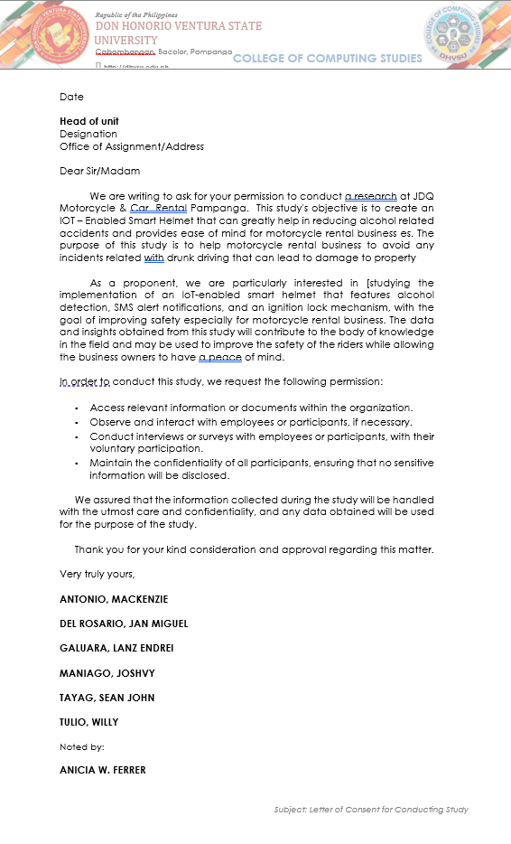
Request Letters (Locale)

APPENDIX C.
Plagiarism Checker Certificate

APPENDIX D.
Grammar Check Certificate

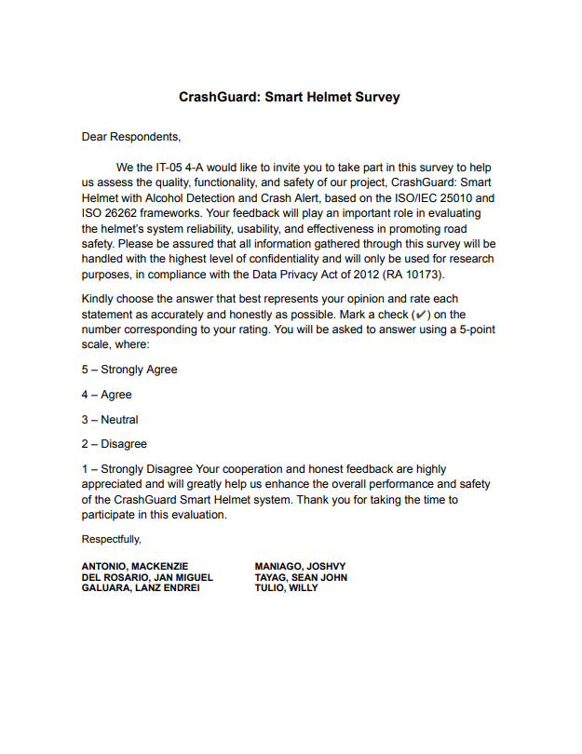
APPENDIX E.
Pre-Survey Questionnaire

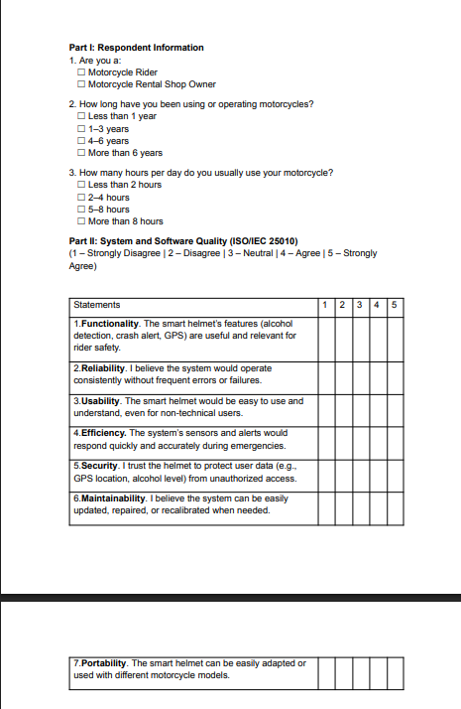

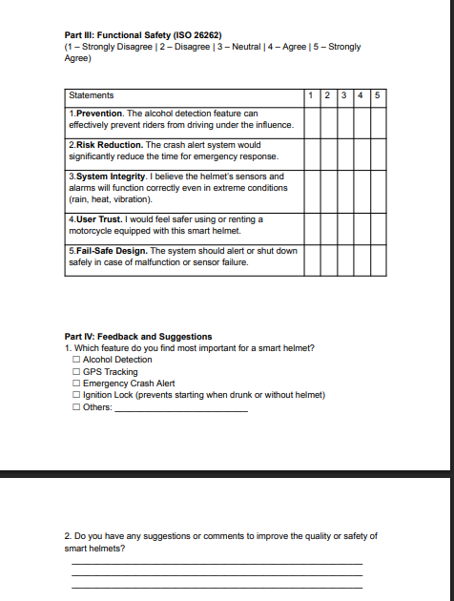

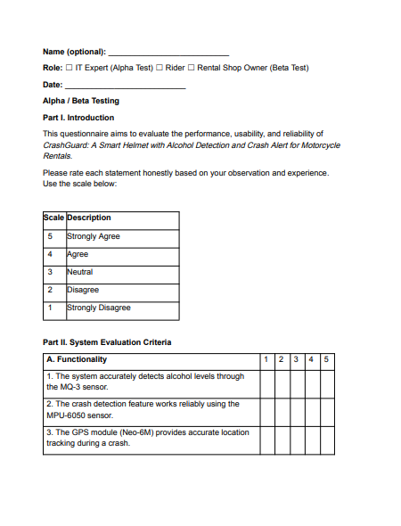
APPENDIX F.
Alpha Test Questionnaire

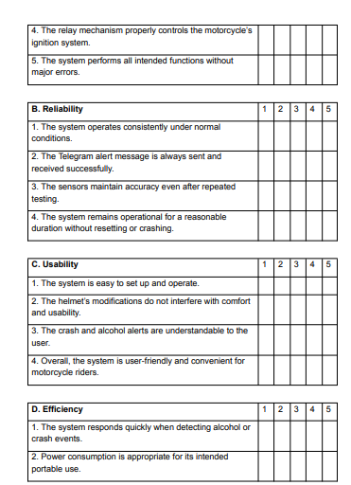

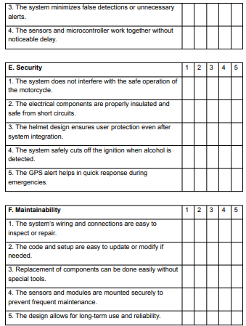

APPENDIX G.
Beta Test Questionnaire

APPENDIX H.
Alpha Test Results Summary

APPENDIX I.
Beta Test Results Summary

APPENDIX J.
System Screenshots
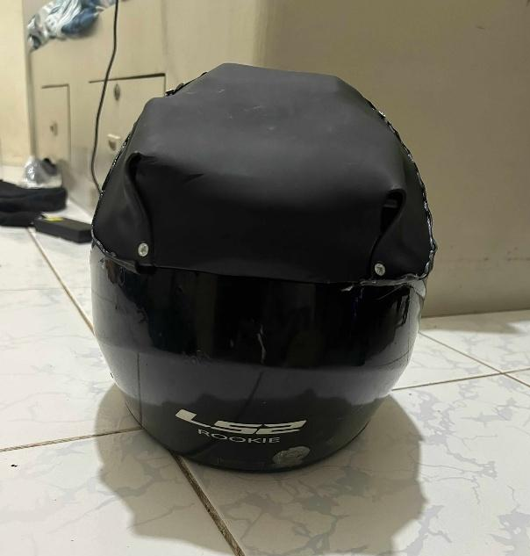
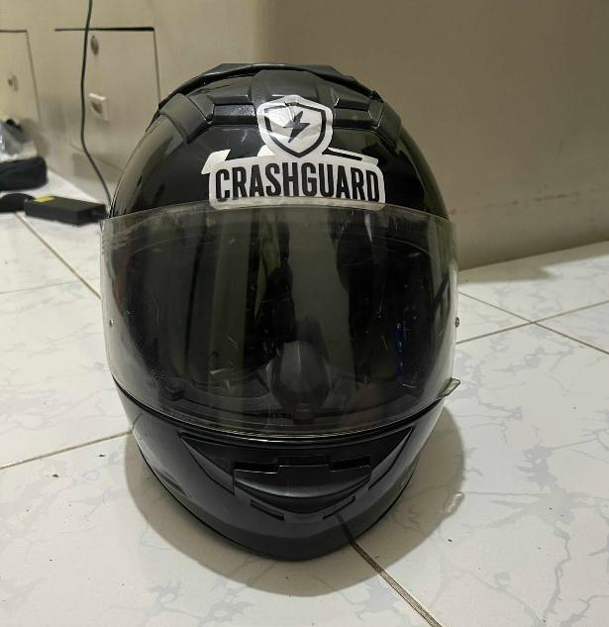

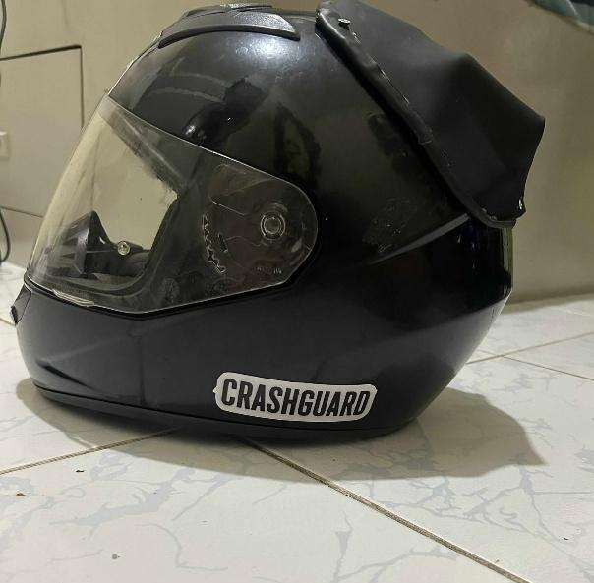
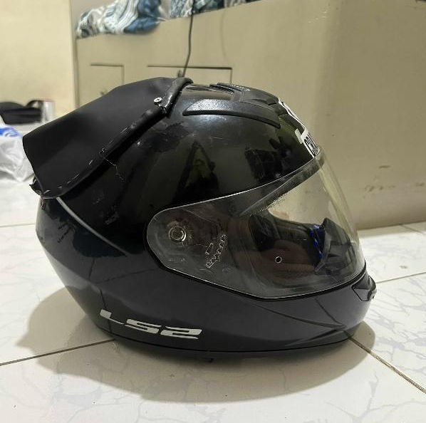

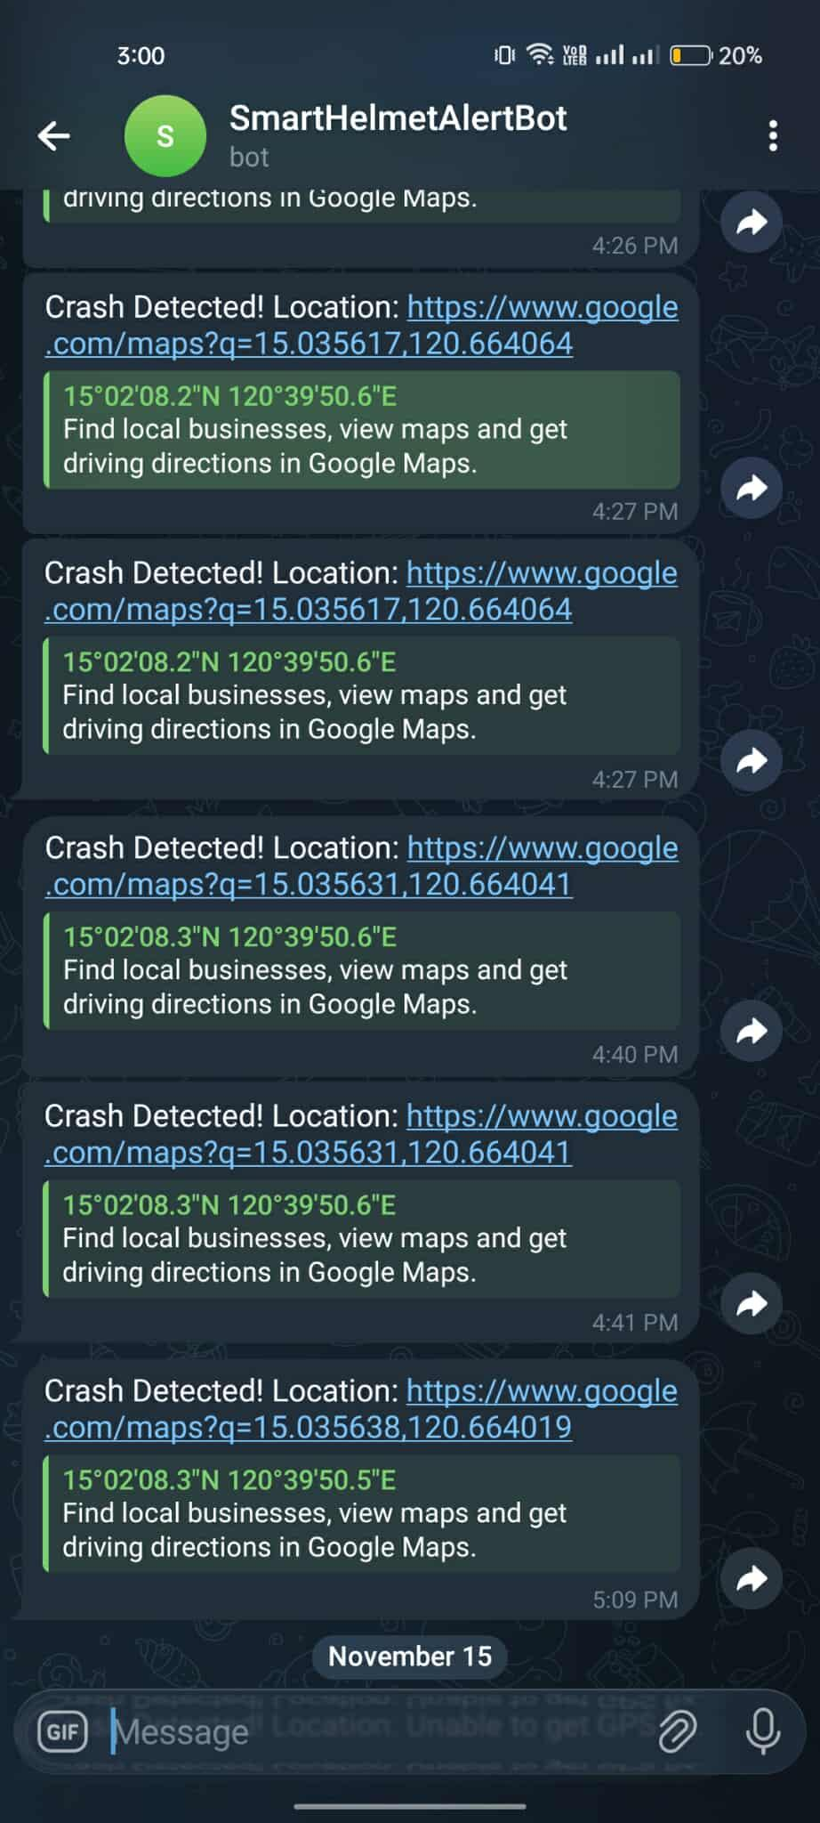
APPENDIX K.
User Manual
When you switch on the motorcycle, the connected ESP32 (Arduino) will also power on. The ESP32 on the helmet and the one on the motorcycle will automatically connect to each other.
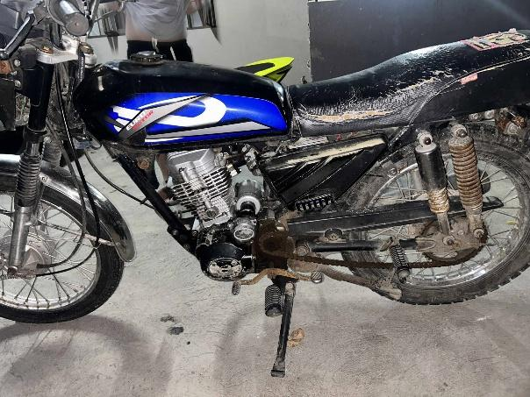
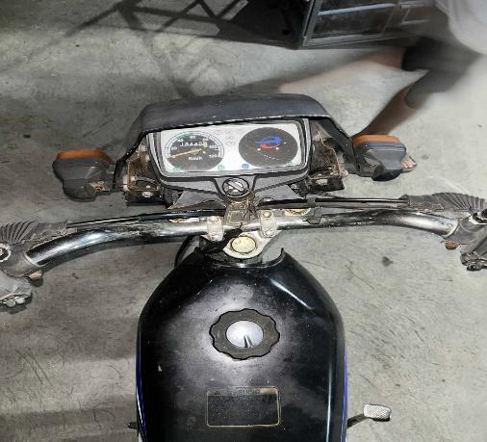

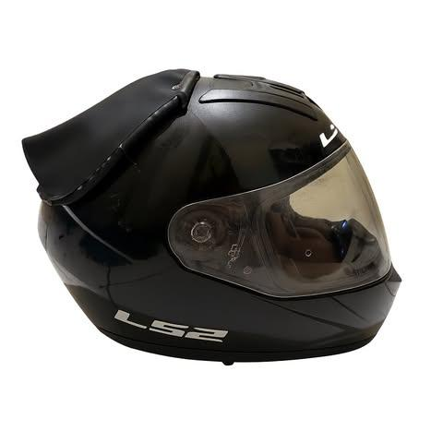

APPENDIX L.
Source Code
#include <Wire.h>
#include <Adafruit_MPU6050.h>
#include <Adafruit_Sensor.h>
#include <TinyGPSPlus.h>
#include <WiFi.h>
#include <HTTPClient.h>
#include <esp_now.h>

#define FSR_PIN 35
#define MQ3_PIN 34

#define RXD2 16
#define TXD2 17

Adafruit_MPU6050 mpu;
TinyGPSPlus gps;
HardwareSerial neogps(2);

const char* ssid = "Oyu";
const char* password = "12345678";
String botToken = "8361699181:AAGG7ZQXNTS5csU2eD5VyN2S6tQI2hGmARw";
String chatID = "1369653927";

uint8_t slaveAddress[] = {0x38, 0x18, 0x2B, 0xEB, 0x97, 0xB0}; // Replace with your slave MAC
esp_now_peer_info_t peerInfo;

bool crashDetected = false;
unsigned long lastCrashTime = 0;
const unsigned long crashCooldown = 10000;

void sendTelegramMessage(String text) {
if (WiFi.status() == WL_CONNECTED) {
HTTPClient http;
String url = "https://api.telegram.org/bot" + botToken + "/sendMessage?chat_id=" + chatID + "&text=" + text;
http.begin(url);
http.GET();
http.end();
}
}

void OnDataSent(const wifi_tx_info_t *mac_addr, esp_now_send_status_t status) {
Serial.print("ESP-NOW send status: ");
Serial.println(status == ESP_NOW_SEND_SUCCESS ? "Success " : "Fail ");
}

void setup() {
Serial.begin(115200);
Wire.begin();
neogps.begin(9600, SERIAx`x1L_8N1, RXD2, TXD2);

if (!mpu.begin()) {
Serial.println("MPU6050 not detected!");
while (1) delay(10);
}

mpu.setAccelerometerRange(MPU6050_RANGE_8_G);
mpu.setFilterBandwidth(MPU6050_BAND_5_HZ);

WiFi.mode(WIFI_AP_STA);
WiFi.begin(ssid, password);
Serial.print("Connecting WiFi");
while (WiFi.status() != WL_CONNECTED) {
delay(500);
Serial.print(".");
}
Serial.println("\nWiFi Connected!");

if (esp_now_init() != ESP_OK) {
Serial.println("ESP-NOW Init Failed!");
return;
}
memcpy(peerInfo.peer_addr, slaveAddress, 6);
peerInfo.channel = 0;
peerInfo.encrypt = false;
if (esp_now_add_peer(&peerInfo) != ESP_OK) {
Serial.println("Failed to add peer");
return;
}
esp_now_register_send_cb(OnDataSent);

Serial.println("System Ready ");
}

void loop() {
int fsrValue = analogRead(FSR_PIN);
int mq3Value = analogRead(MQ3_PIN);
sensors_event_t a, g, temp;
mpu.getEvent(&a, &g, &temp);

float accelMag = sqrt(a.acceleration.x * a.acceleration.x +
a.acceleration.y * a.acceleration.y +
a.acceleration.z * a.acceleration.z);

Serial.printf("FSR=%d MQ3=%d Accel=%.2fG\n", fsrValue, mq3Value, accelMag);

int command = 0; // 0 = lock, 1 = unlock

if (fsrValue > 50 && mq3Value < 2300) {
command = 1; // Unlock
Serial.println("Helmet ON - Ignition UNLOCKED ");
} else {
command = 0; // Lock
Serial.println("Helmet OFF or Alcohol Detected - Ignition LOCKED ");
}

esp_now_send(slaveAddress, (uint8_t *) &command, sizeof(command));

if (accelMag > 20.0 && millis() - lastCrashTime > crashCooldown) {
crashDetected = true;
lastCrashTime = millis();

Serial.println("Crash Detected!");

String gpsText = "";
while (neogps.available() > 0) {
if (gps.encode(neogps.read())) { gpsText = "Crash Detected! Location: https://www.google.com/maps?q=" +

if (gps.location.isValid()) {
String(gps.location.lat(), 6) + "," +
String(gps.location.lng(), 6);
sendTelegramMessage(gpsText);
Serial.println(gpsText);
break;
}
}
}

if (gpsText == "") {
sendTelegramMessage("Crash Detected! Location: Unable to get GPS fix.");
Serial.println("Crash Detected! No GPS Fix.");
}
}

delay(500);
}
#include <WiFi.h>
#include <esp_now.h>

#define RELAY_PIN 26

void OnDataRecv(const esp_now_recv_info *info, const uint8_t *data, int len) {
int command;
memcpy(&command, data, sizeof(command));

Serial.print("Received Command: ");
Serial.println(command);

if (command == 1) {
digitalWrite(RELAY_PIN, LOW); // Unlock (ON)
Serial.println("Ignition UNLOCKED ");
} else {
digitalWrite(RELAY_PIN, HIGH); // Lock (OFF)
Serial.println("Ignition LOCKED ");
}
}

void setup() {
Serial.begin(115200);
WiFi.mode(WIFI_STA);
pinMode(RELAY_PIN, OUTPUT);
digitalWrite(RELAY_PIN, HIGH); // Start locked

if (esp_now_init() != ESP_OK) {
Serial.println("ESP-NOW init failed");
return;
}

esp_now_register_recv_cb(OnDataRecv);
Serial.println("Slave ready ");
}

void loop() {
delay(1000);

APPENDIX M.
Expert/Alpha Tester Profile
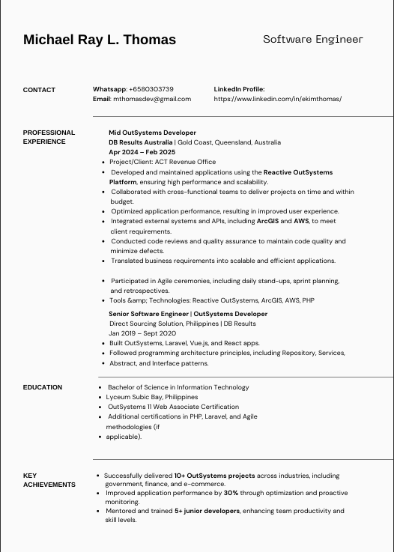

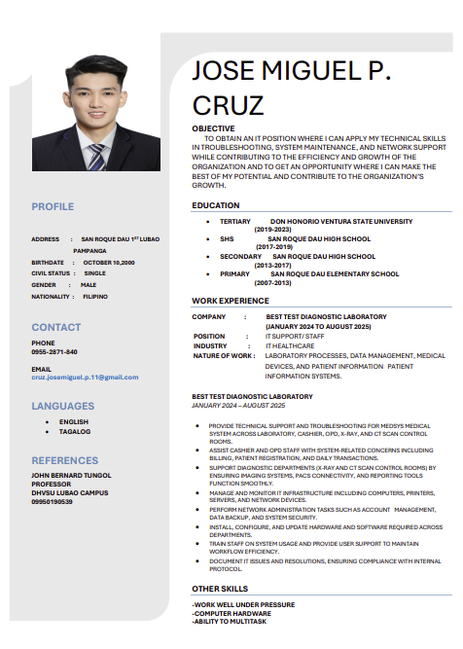



APPENDIX N.
Researchers Curriculum Vitae

APPENDIX O.
Research Documentation Pictures
